Screenshots of Figures 1, 3, 4

Below are screenshots of the dashboards for each figure. As noted in the instructions, you will likely need to adjust font sizes to ensure all text displays correctly on your monitor.

An example of how the screen affects this can be seen using Figure 4 below.

# Figure 1

# 

# Figure 3

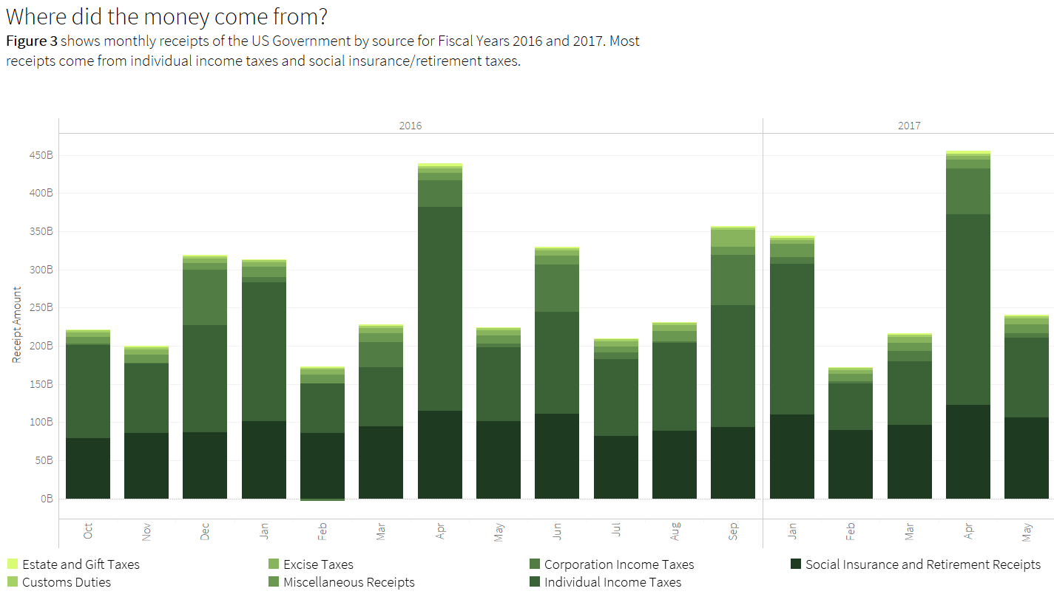

# Figure 4

Note: all **font sizes were the same** in the Tableau workbook. I simply took a screenshot while the dashboard was in full-screen mode on my monitor and on my laptop. The title, body text, axes, labels, and legends’ text all appear differently sized.

## From Monitor

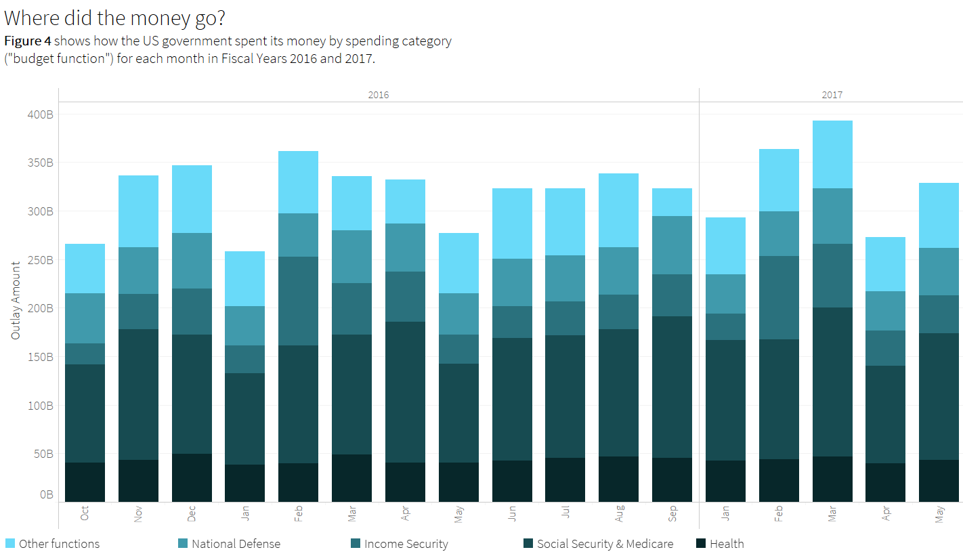

# Figure 4

## From Laptop Screen

